**Robot Design Documentation**

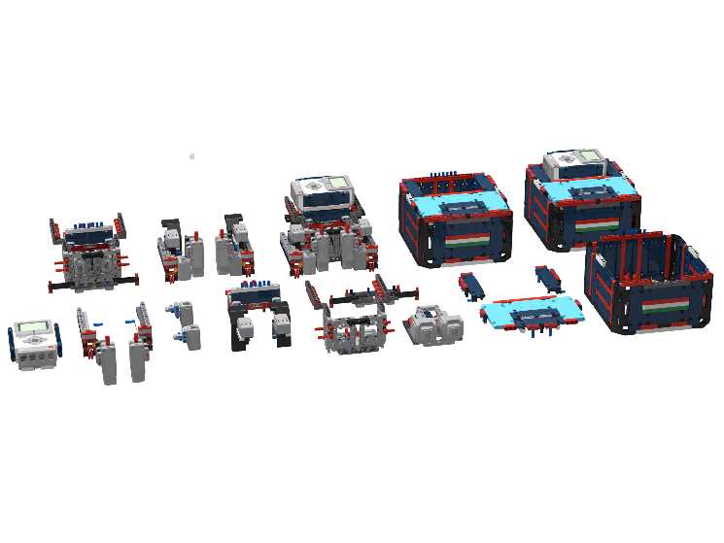Team TövisASAP 2019

Documentation for our great and innovative **OrbitBot** robot  
**Modular, Stable, Precise, Gentle  
S.D.P.S.I.**

**Systematic Design Process for Strategy and Innovation**

**We have applied**

**Systematic Design Process for Strategy and Innovation  
S.D.P.S.I.**

**Pre-Season  
Design System**

**In-Season  
Design System**

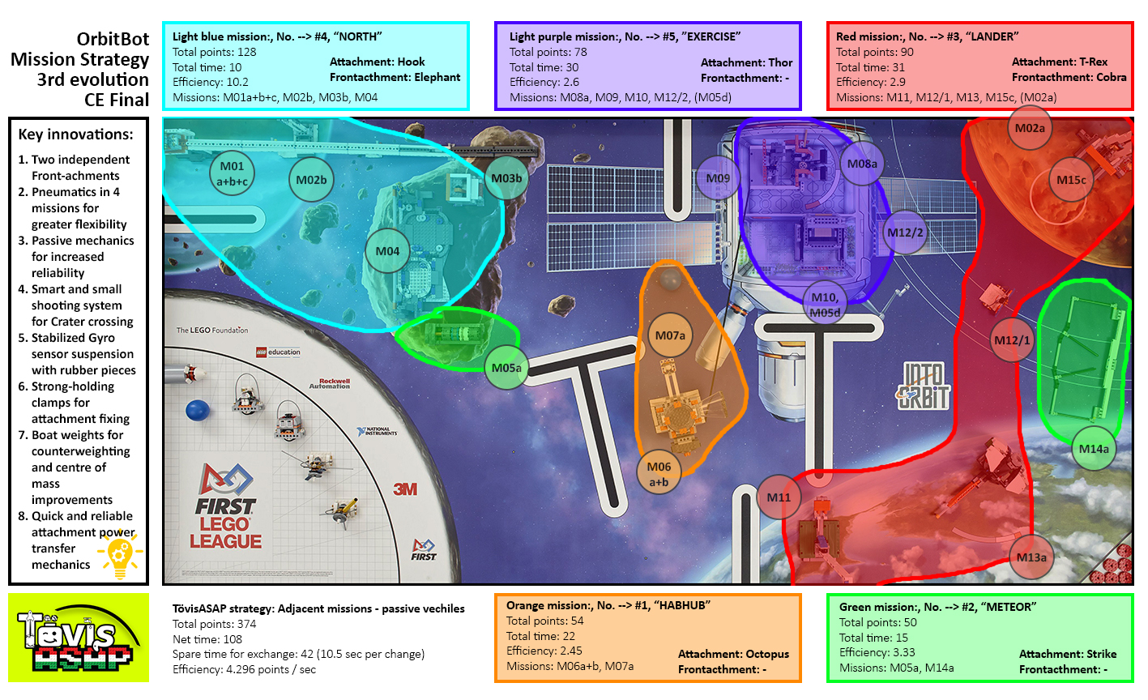**Mission Strategy Central European Final**

Our goal: very clear, purposefully to maximize points

**Mission Strategy**

We divide the mat, like this we could established the most effective rounds. We measured the **point/second** progress too, so we know in witch round to optimize.

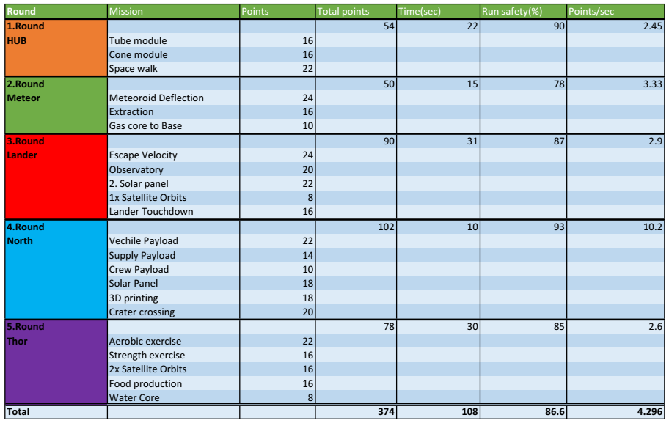

**Mission Strategy**

**Attachments and Font-achments for Base robot**

|  |  |  |
| --- | --- | --- |
|  | Attachment | Front-achment |
| 1.Round HUB | Octopus | X |
| 2.Round Meteor | Strike | X |
| 3.Round Lander | T-Rex | Cobra |
| 4.Round North | Hook | Elephant |
| 5.Round Thor | Thor | X |

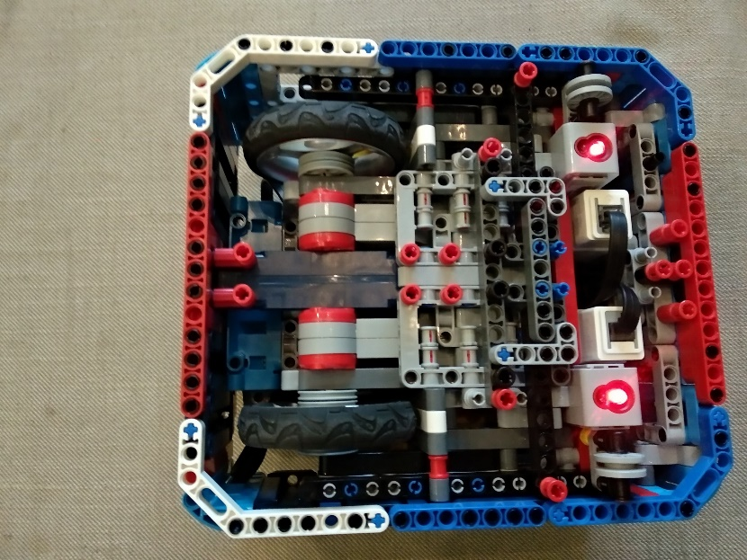**Durability**

Our goal: sound construction, no repairs

Robust, Stable Structure

DRIVEN WHEELS:   
- the wheels are fixed by a long axle, a wheel is fixed with 4-4 pulley wheels, that don't touch the motor and the side  
- The wheels are attached by the axle to the frame, therefore, it cannot be strained downward or upward.  
- The wheels are made of metal, so the tire is less pressable.  
-They are fixed to the frame at 3 points, this making them stable.

UTILITY WHEELS: - the two wheels are fixed by 1 to 1 axes, these axes are inserted, that the frame obstructs the removal.  
- Both wheels have two units.  
- If it be larger, it would make the robot harder in turning, as it would make a smaller surface contact with the mat.

LARGE MOTORs: - it is attached to the suspension, the wheel and the frame with a axle, this secure that it does not move.  
- The large motors look backward, because the big wheels are at the back, they look back, because if they want to look ahead, these wouldn't fit.  
- It looks back because with the rear wheel drive we can made a stronger, faster robot  
FRAME: - the frame is rectangular, but its corners are curved because it can easily turns next to the wall.  
- it keeps the brick in its place  
-13 units high, 24 units long and 23 units wide  
.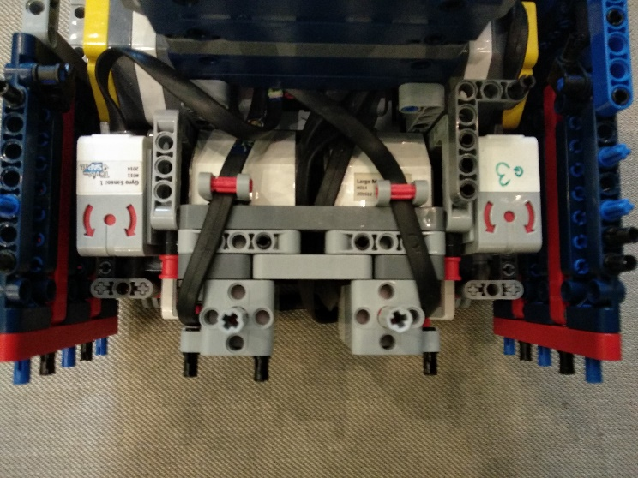BRICK: -the brick is on the back of the robot, its sides are tightly secured to the frame.  
- Cables are protected by a panel so that they do not go into anything.  
- There is also a separate channel to avoid contact with the wheel.

IAM AND THE MEDIUM MOTORS: - the middle motors are at the front of the robot, so we can take the rotation directly, without gear transmission.  
- The IAM fixed to the medium motors with axles, which makes it easy for the engine to rotate the attachment.  
- The medium motors are attached to the suspension, the wheel and the frame.  
IAM = Innovative Attachment Mechanism

GYRO: - the gyro sensor is attached to the rubber so that when the robot moves it will remain roughly in place.  
CABLE DRAINING: - the cables are clamped down so that they do not get caught in anything.  
- The gyro sensor's cable is placed above the wheel on a "mudguard"  
We've also made the robot's Lego Digital Designer version so we can attempt freely without risk

**Mechanical Efficiency**

Our goal: ideal for tasks, can be used universally

Our robot is modular so it's easy to disassemble.  
This is very useful if we need to modify or have to replace a motor or sensor in the robot or have an idea for improvement. There are 6 main modules in our robot: frame, large motors, medium motors, brick, sensors, and the robot's center.

**Frame:** Includes all (usually panel) elements that hold unite and cover the robot.

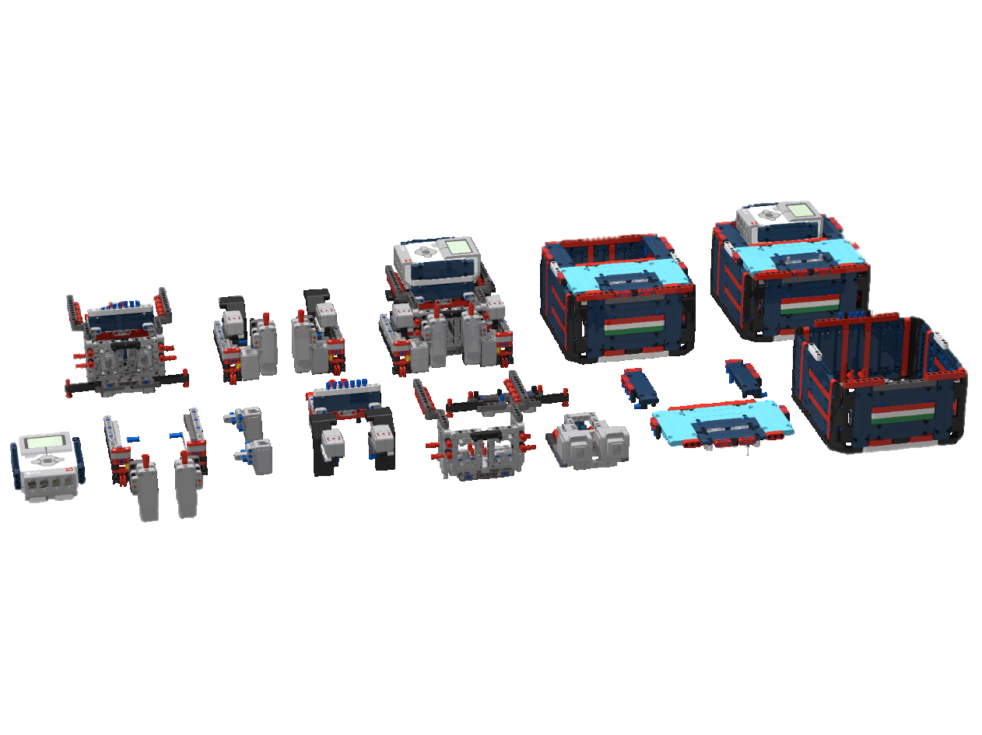**Large motors:** It includes the two large motors and a special frame on them which can fix the motors into the center of the robot. This part also includes the pully wheels which attach the wheels.  
**Medium motors:** The two medium motors, the middle part frame and the out-of-frame outlets are included in this module.  
**Brick:** This module contains an Ev3 LEGO brick and the fixing frame below the brick.   
**Sensors:** There are two opposing element in this module. Both have 1-1 color sensors and 1-1 gyro sensors. Furthermore, both elements have a small wheel.  
**Centre:** This module contains 6 beamframes and a few complementary elements. This module holds everything in one piece.

**Precision**

Our goal: solved all the tasks with high precision and reliability

We always choose the right speed for the different models. It is going slower in curvy parts to make it more accurate. At the end of the fast sections, the robot slows down for accuracy. **Before the models the robot slow down to be more accurate**. For some models, the robot go over more times to don't miss.

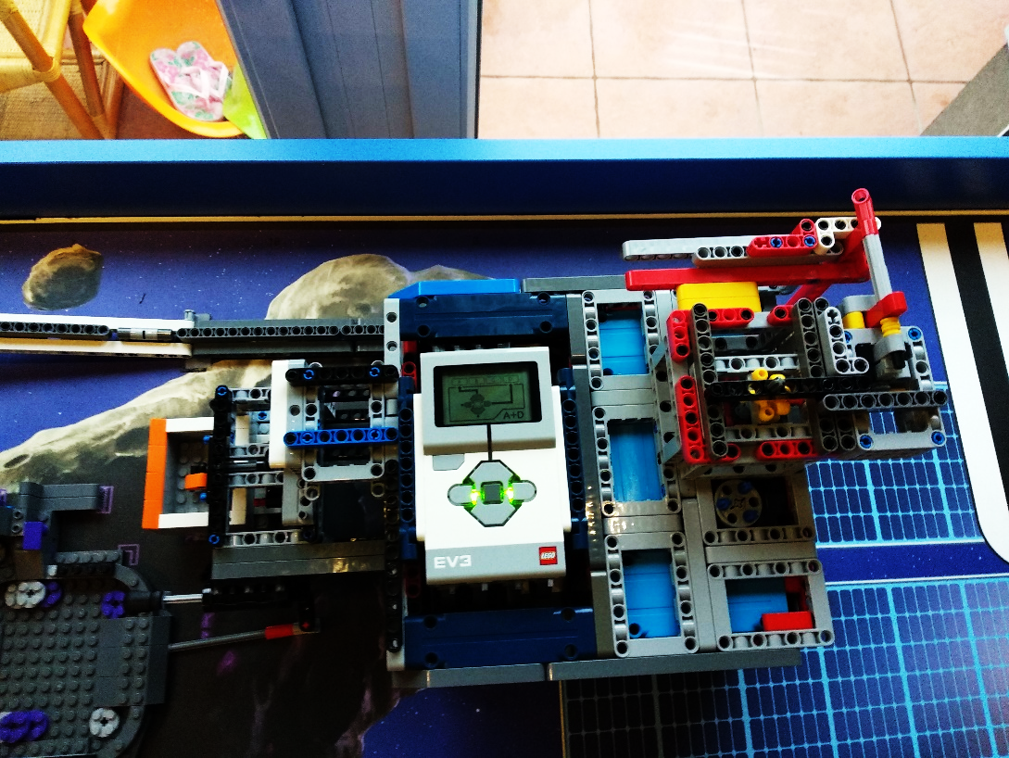 We prefer to use deflectors that help in precision. We also turn the wall to our advantage, so the robot can easily adjust without lines. Our ballasts roll on wheels and do not slip, so they can always stay next to the wall.

We are also adjusted to properly stable models. The robot does not make any sudden movements to avoid slipping and make a mistake. Slipping is also hindered by gradual acceleration and deceleration at turning and at going straight.

**Strength, Sustainability**

Our goal: Robot goes easy on structures, objects or itself

* **Software:**

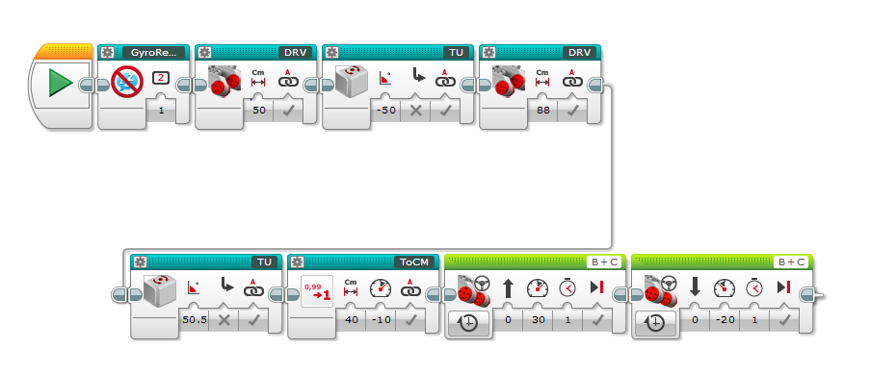 In our program, we are gradually changing the speed to protect models. We are approaching everything slowly, carefully and guardedly.

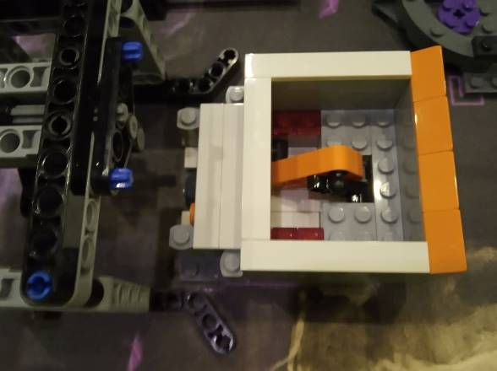

* **Hardware:**

Our robot is able to exert large strength, because of the proper transmission, but we do not use it for wrecking.   
We like to use clamping mechanism to reduce the chance of destruction.

**Reliability**

Our goal: excellent, novel, outgoing, successful in each task

* Our Robot strive successfully solve all tasks
* It solves logically-related tasks with proper and newly designed attachments
* Our robot does not need to be saved in any round
* We are proud for our programs, the result of many of our work E.g.:
  + **DRV, TU, CURV, ToCm**
* There is no planned destruction in our program
* **We can easily exit from any program using MasterMenu**
* We use the most similar motors and sensors as possible to reduce the chance of mistake from the difference between motors and sensors

**Understandability**

Our goal: very understandable programming, optimized code

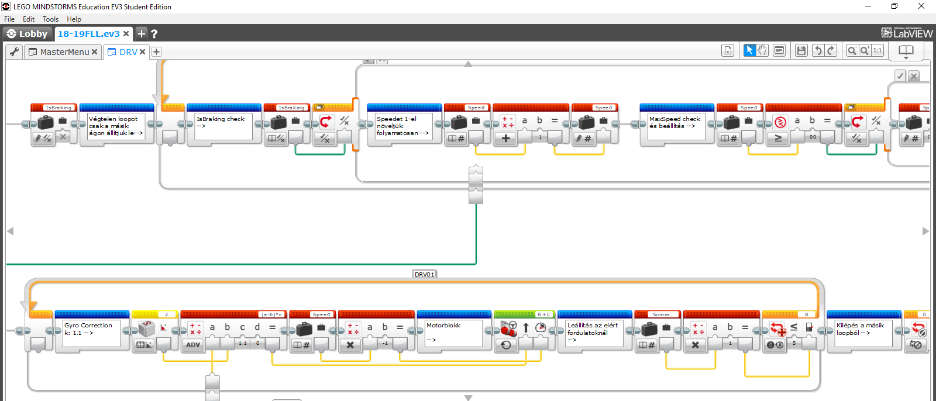 We have a lot of comments to make our programs transparent to anyone and especially to ourselves.

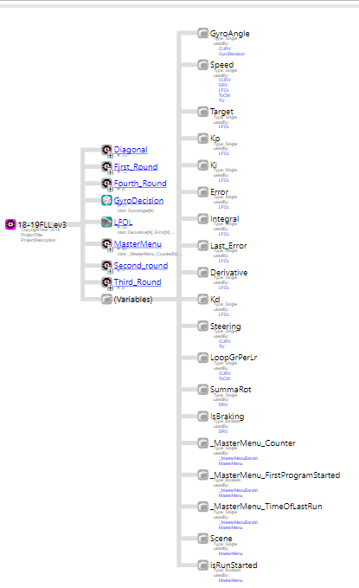The main features we can't perform with one green block are included in MyBlocks to keep our program not long but transparent.  
Our often used MyBlocks are named targeted, short, unique names (eg DRV, TU, ToCM, etc…). This is done because of simplicity and transparency, optimization / * and to make the interpreter we want to use easily. * /In our programms we use a lot of loop and switch.

We use subordinated MyBlocks in MasterMenu main programm for transparency and efficiency.  
When we start the robot, there is another side outside the robot run where we can reset the gyros and everything else.

In previous years, there were several times that we had unnecessary variables in our project and these slowed down the robot, so this year we reviewed the final project with the tool called Ev3TreeVis and we could filter out the useless variables what left in it.

**Autonomy**

Goal: robot acts autonomous all the time, without intervention

When we just have possibility, adjusted to the wall, for this reason don’t need to intervene. We navigate like, we accentually do not collide to the task models. We use two gyro-sensor, because with these we navigate easier.

By using „CURV” Myblock we can easy, but more precisely do maneuver. Usually we don’t need help, but if we need we can easily start again the cycle with the Master Menu.

With the „TU” Myblock easy and accurate the turn. Usually we go next to the wall, because the move is straighter.

**We always go that route which is the most safe to our robot.**

**Independence and navigatio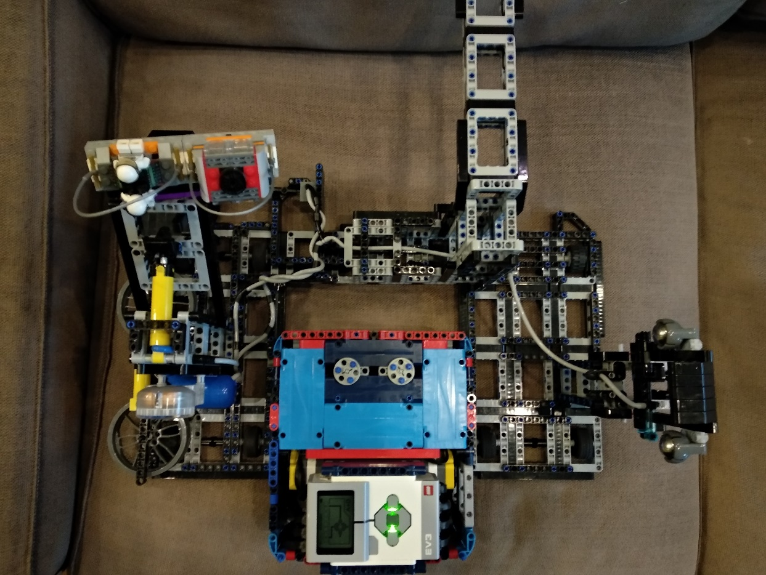n**

If we have the opportunity we align to the wall, therefore we don't need intervention. We navigate to don't get into any model. We use two gyro sensors to make the navigation more precise.

With **"CURV" Myblock** we can maneuver simply, but more accurately. In generally it not need intervention, but when this happens, we can easily restart the round with MasterMenu.

With **"TU" Myblock** we can easily and accurately turn.

We go next to the wall in many rounds, that move as straight as possible.

We always try go on the way, that is the **safest** for our robot.

**Sensor usage/ Location**

Our goal: using varied sensors for navigation

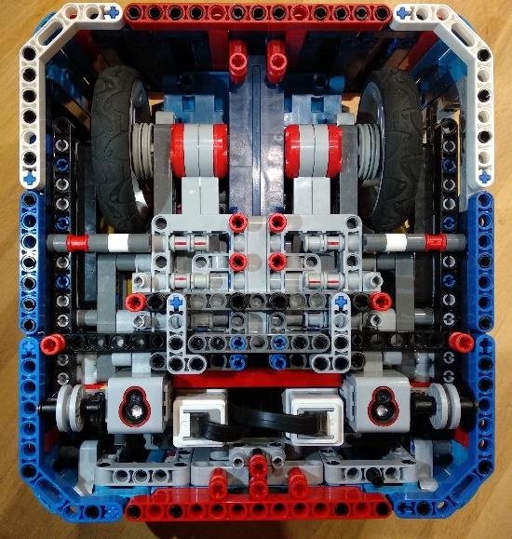

In total the robot is equipped by 4 sensors: 2 gyro and 2 colour sensors.

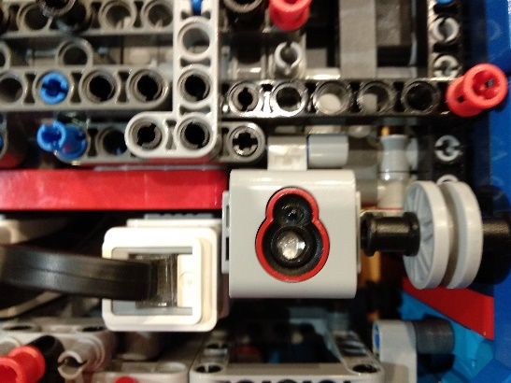**Colour sensors**

They are fixed, we used all three tied-down points of the sensors. The two colour sensors are used for accurate positioning and positioning to the line. They can be found at the front and the bottom of the robot, this allows them to perceive colours accurately. Positioning of the sensors: in the front-end, at the bottom and at the side of the robot, attached to the internal case. To the middle of the centerline and the side of the robot. At the opposite side of the big wheels and next to the auxilliary wheels. The distance between the centers of the sensors is 1 cm or 13 units. We use them in myblock, LFOL, LSQ, ToColor programs. We use them in reflected-light mode. They are shaded from 3 direction, so the light is not disturbing.

**Gyro sensors**

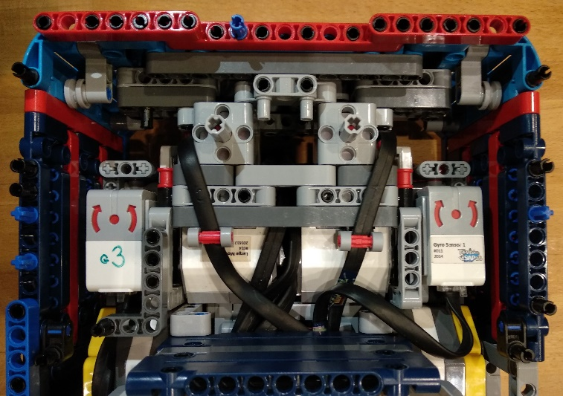These sensors are fixed by rubber in order to be always stable in all type of circumstances. They are used for the accurate positioning of the robot. Positioning of the sensors: In the front-center, above, attached to the internal case. They are in the middle of the centerline and the side of the robot. They are above the colour sensors. The distance between the centers of the sensors is 13 cm or 17 units.

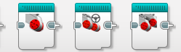**Subroutines/ Loops  
/ Variables**

Our goal: meaningful use of variables, loops and myblocks

|  |  |  |  |  |  |  |
| --- | --- | --- | --- | --- | --- | --- |
| **Command** | **Variable 1** | **Variable 2** | **Variable 3** | **Variable 4** | **My Block** | **Description** |
| **GyroReset** | GyroPort | Not Required | Not Required | Not Required | GyroReset | Resets the chosen Gyro sensor |
| **GyroDecision (Static)**(Can't use in interpreter) | Output: GyroAngle | Not Required | Not Required | Not Required | GyroDecision | Chose the good working Gyro  or when all working correctly  returns the avarge of the two  Gyros |
| **STALL** | Not Required | Not Required | Not Required | Not Required | STALL | Stops the robot when it  can't move |
| **CURV** | Steering | Angle | Speed | Mstop 1 = true 0 = false | CURV | Can move the robot to  the adjusted angle with the  adjusted steering |
| **TU** | Angle | Steering 0 = -100 1=100 | Mstop 1 = true 0 = false | Not Required | TU | Turns the robot to the  adjusted angle with calculated  speed |
| **DRV** | Cm | Mstop 1 = true 0 = false | Not Required | Not Required | DRV | Moves forward to  the adjusted Cms with calculated  speed and with Gyro correction |
| **ToCM** | Cm | Speed | Mstop 1 = true 0 = false | Not Required | ToCM | Moves the robot to the adjusted  Cms with the adjusted speed |
| **LFOL** | Cm | Port | Mstop 1 = true 0 = false | Not Required | LFOL | Follow line with both sensors for a  number of degrees. |
| **ToColor (Static)** | Speed | Relation | RLI | Not Required | ToColor | Goes to the needed color |
| **LSQ** | Direction 1 = forward 0 = backward | Not Required | Not Required | Not Required | LSQ | Adjust the robot to a line |
| **_MasterMenuBandA** | Not Required | Not Required | Not Required | Not Required | _MasterMenuBandA | Contains the robot run part of  MasterMenu |
| **MM_Display_Runs (Static)** | Number of Run | Not Required | Not Required | Not Required | MM_Display_Runs | MasterMenu - Displays the current  run index and name |

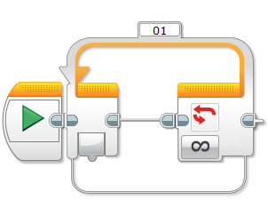 **Loops / Cycles, MyBlocks**

|  |  |
| --- | --- |
| **Loop név** | Hol? |
| **ValueOfScene** | MasterMenu |
| **_MasterMenu** | _MasterMenuBandA |
| **_MasterMenuVezer** | MasterMenu |
| **_MMACancel** | _MasterMenuBandA |
| **_MMCancel** | _MasterMenuBandA |
| **01** | GyroReset |
| **01_MasterMenuIdozito** | _MasterMenuBandA |
| **01_MasterMenu_TeljesFutas_Idozito** | MasterMenu |
| **02_MasterMenu_TeljesFutas_Idozito** | MasterMenu |
| **DRV01** | DRV, CURV, STALL, ToCM |
| **TU** | TU |
| **LFOL** | LFOL |

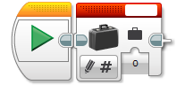

**Variables**

**Subroutines/ Loops / Variables #2**

**Hierarchical program structure**

**Simplicity**

Our goal: Tasks easily solved

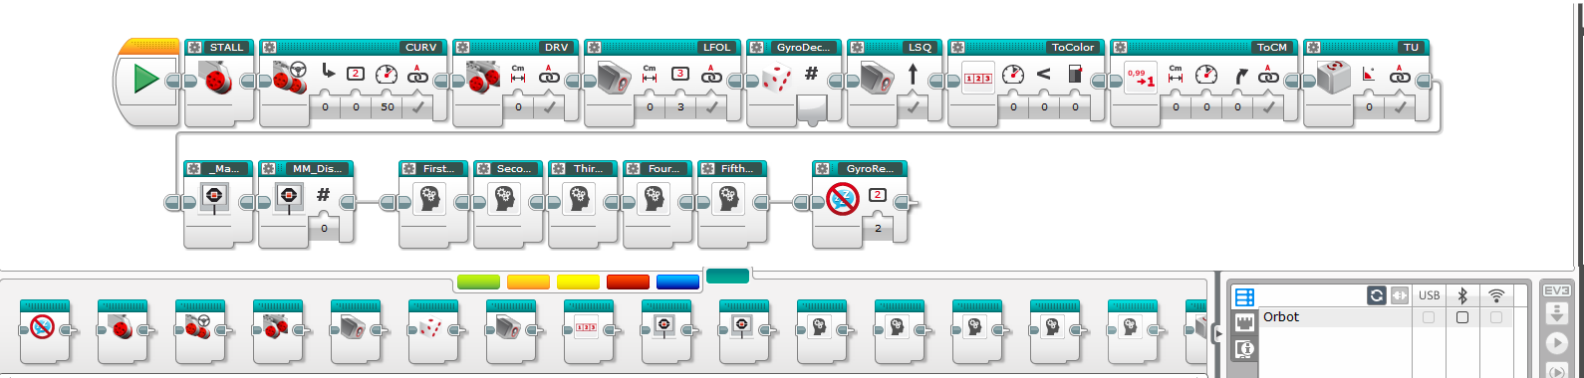 Our software is **easy-to-capture,** **understandable** and **well-structured**. Every MyBlock is indicated by a **clear icon,** because this way it is easily interpretable for **everybody**. We pay attention that the **parameters are indicated by appropriate signs.** In our project we love to use **comments**, because this way every robot move is easy to follow. We don’t complicate our rounds unnecessarily, we try to solve all the issues in the **simplest way**.

All Myblocks

Interpreter

# EV3 Text based interpreter

# Goal, Advantages/Disadvantages

We have created an interpreter for Ev3 mindstorms, because we can use Excel to write a program for our robot, but we still compile the text file we made with Excel with Ev3 Mindstorms. This is simpler. We prepared a program in Lego Mindstorms which can understand our text file as a robot program. Additional innovation is, we use 3 way paralell processing. So we can run not only 1 but 2 or even more blocks together in separate queue branches.

*Interpreter definition: An interpreter is a computer program that directly executes, i.e. performs instructions written in a programming or scripting language, without requiring them previously to have been compiled into a machine language program.*

|  |  |
| --- | --- |
| Advantages | Disadvantages |
| Faster programming  Text-based programming  Easy-to-understand  Clean  Automatic fill  3 parallel queue handling | Can’t use loops/switches  It’s a process to upload to the robot  Could be a source of ‘file missing’ error  No endless parallel branches |

# Excel User Interface

Credit goes to LOL team from 2011, Los Angeles – original version available on the internet (no queueing).

Here you can type the command

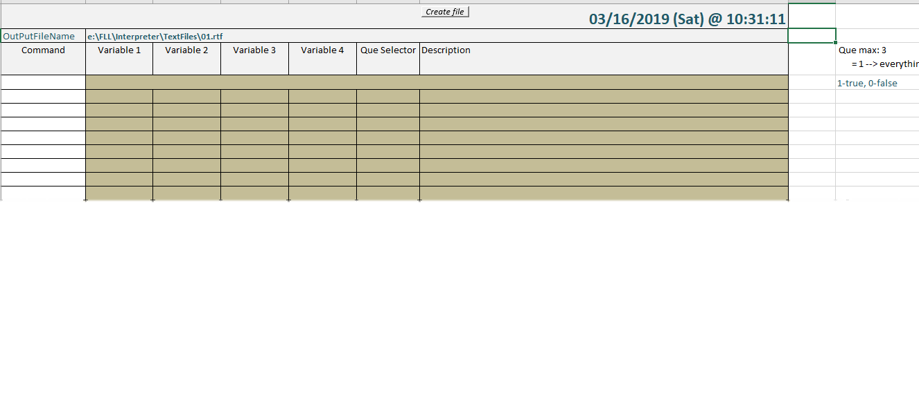

This button generates the text file

# Error Detection

If the command you type in, not exists, it will be red. But if it’s right the top text will turn into the currently used block’s parameters’ names. And you will also see the block’s little description.



# Instructions, list of commands

This page with the blocks, parameters and descriptions called “Instructions”.

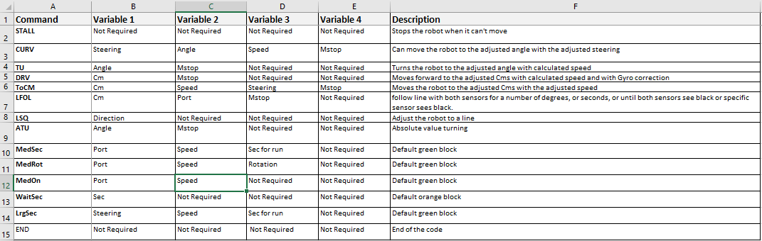

# Some of our missions in interpreter encoded

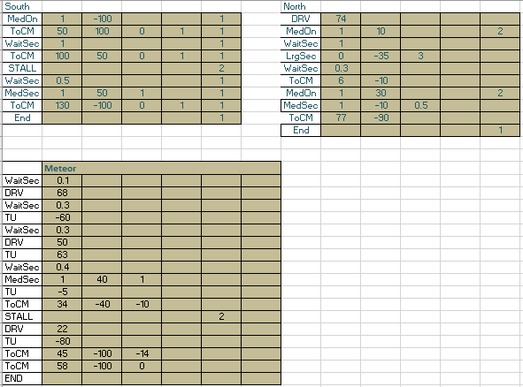

# Visual Basic implementation in Excel

## File making program This is an “existing command check”

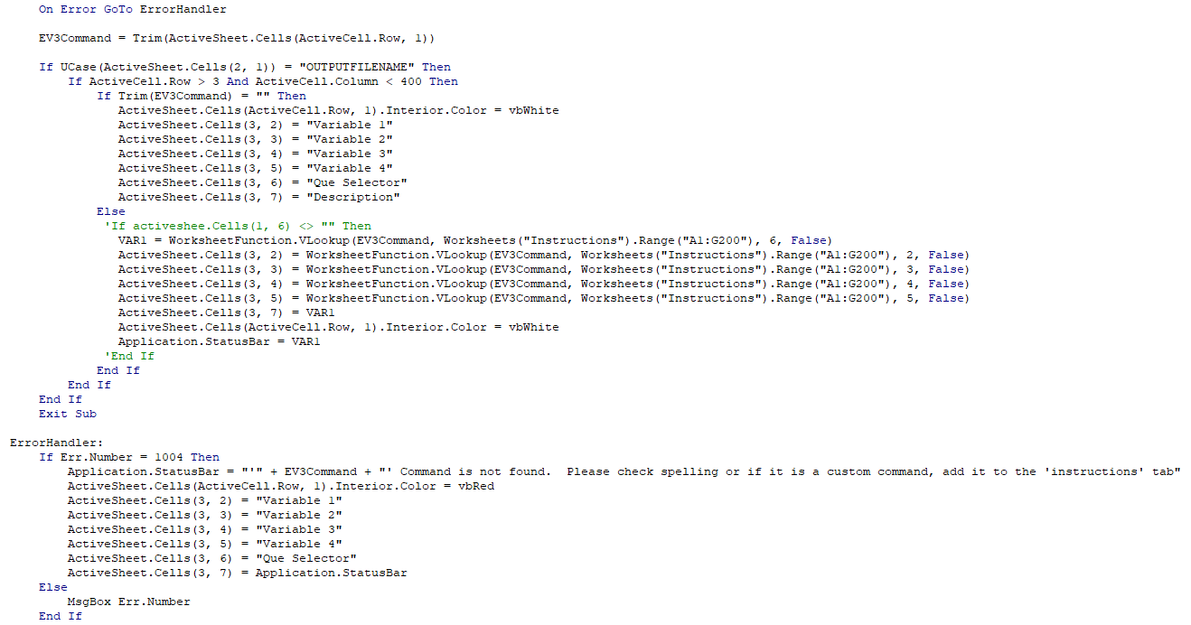

# Our EV3 Implementation

## With this myblock we are able to read the actual file.

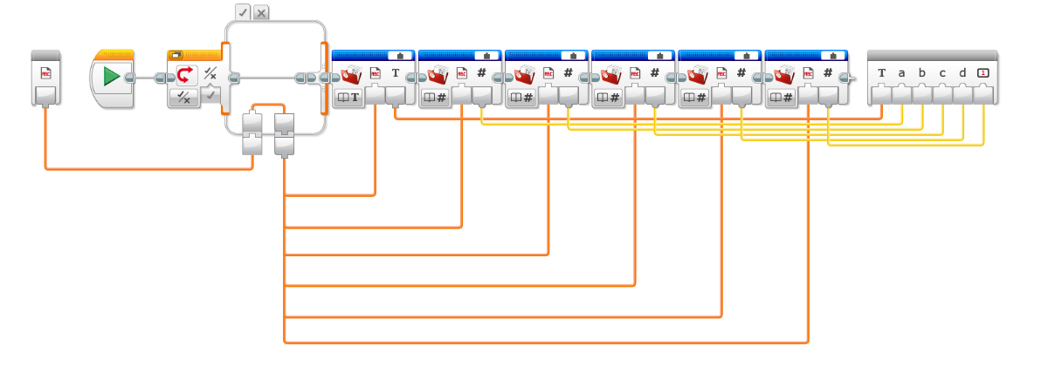

The first que can handle all our Myblocks and basic green blocks

## This program can handle the output file and then can run the executed blocks

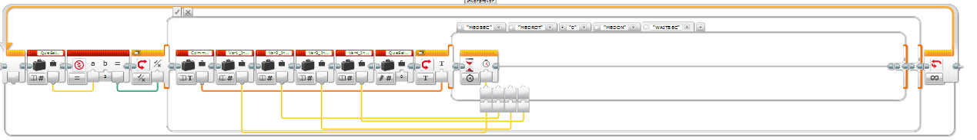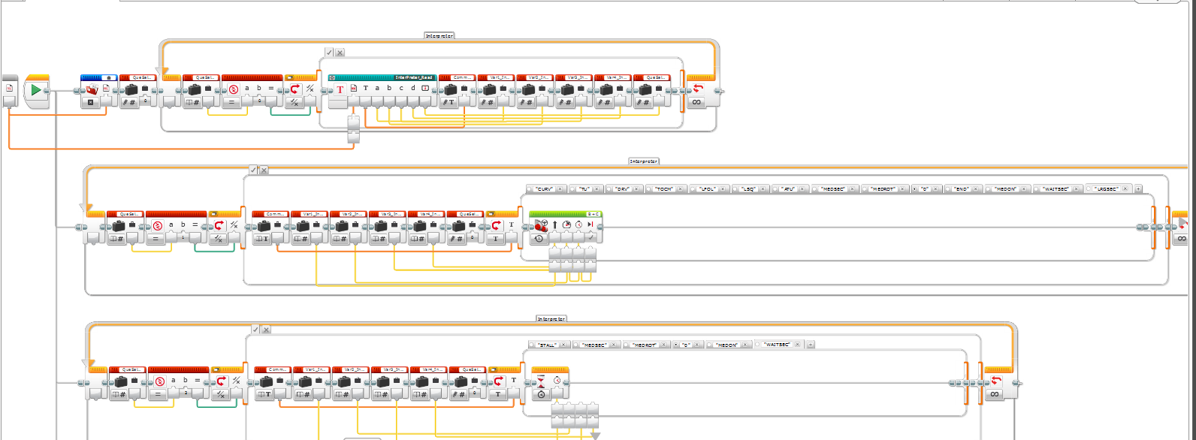

The second que can handle the basic green medium motor mover blocks and the STALL and wait

The third que can handle the medium motor mover blocks and the wait block

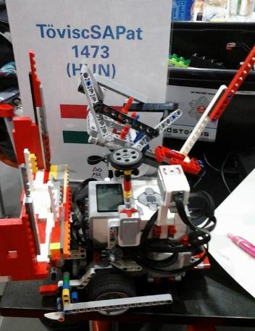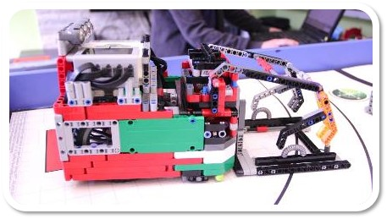

**Design Process**

**Robot Evolution by years**

**2016 Animal Allies**

**2014 World Class**

**Tövis&ASAP 2018 prototypes**

**2015 Trash Trek**

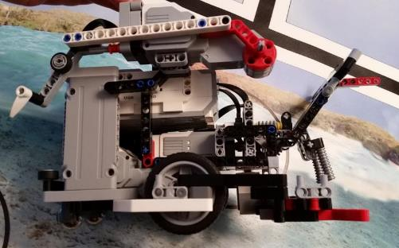

**2017 Hydro Dynamics**

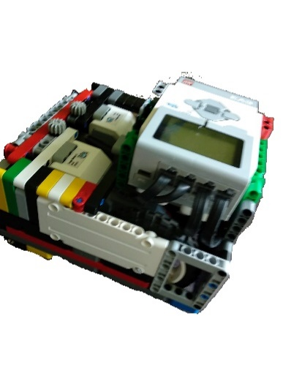

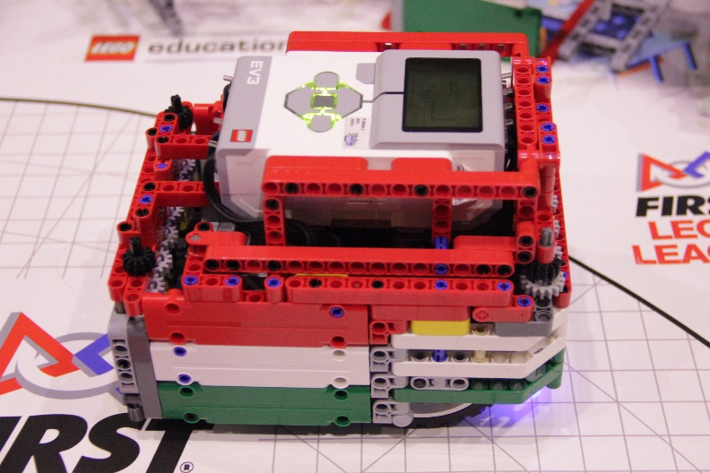

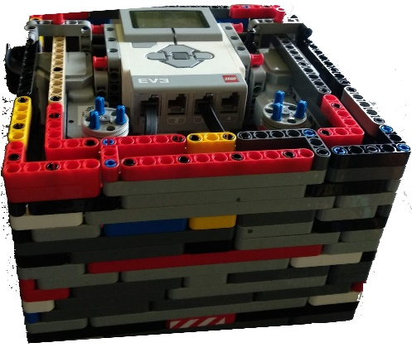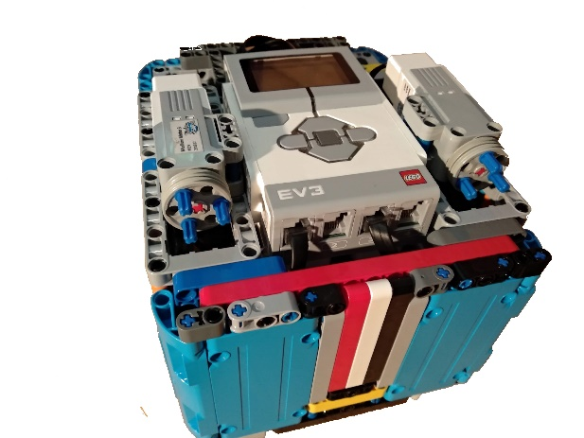

Our goal: very clear, purposefully to maximize points

**Mission Strategy old/Semi**

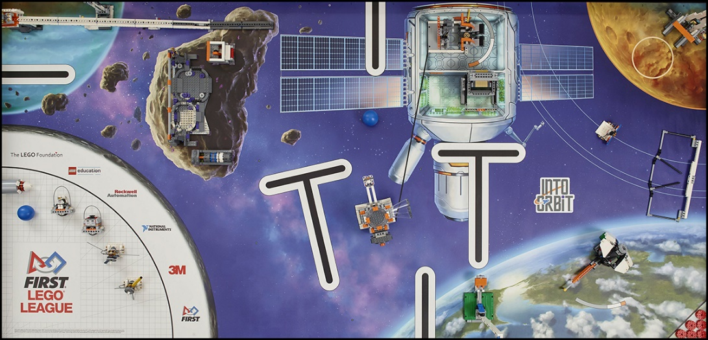1.kör: Extraction; Habitation hub – Gerhard kiszedés, Tube Module; Hazatérés

2.kör: Önjáró kitolás, Crater crossing lecsapás, Space travel, Hazatérés

3.kör: Önjáró kitolás, Escape velocity, Observatory, Cone modul, Gerhard berakás, Hazatérés

4.kör: Strength exercise, 3D printer, Crater crossing lövés, Labda hazalövés, Hazatérés

5.kör: Meteoroid Deflection, Satellite Orbits x3, Lander Touch-Down, Gas core, Lego brick

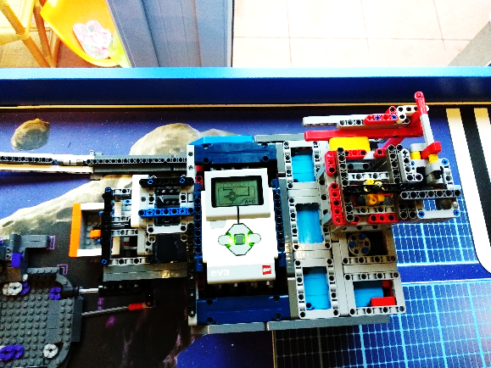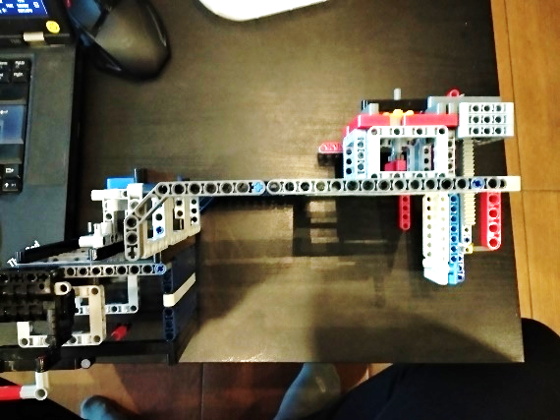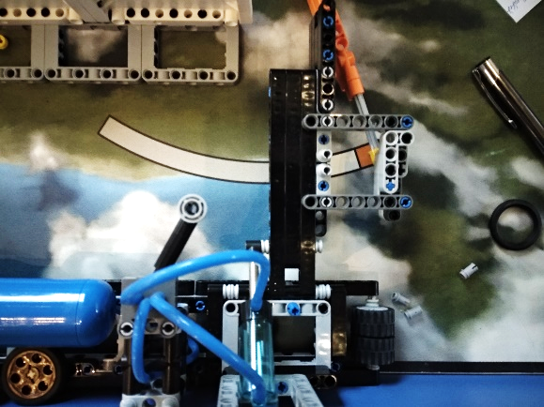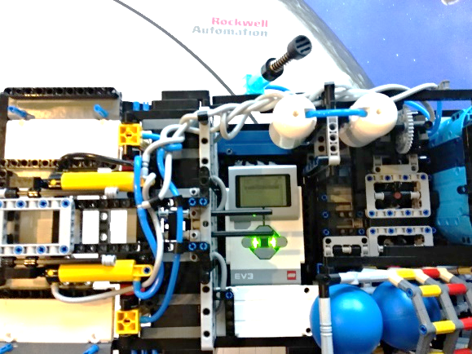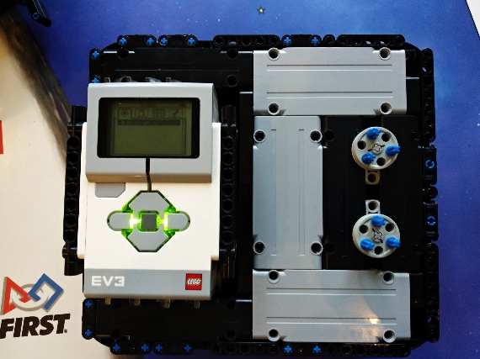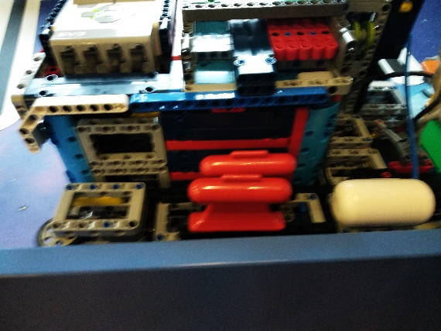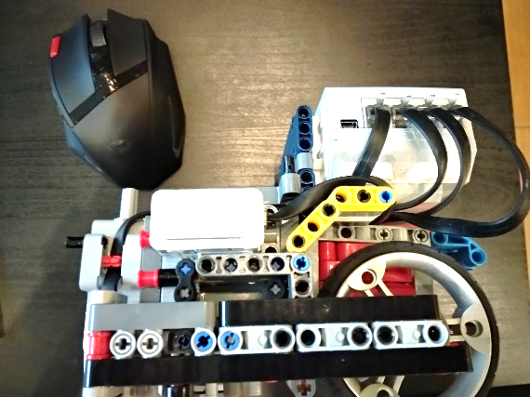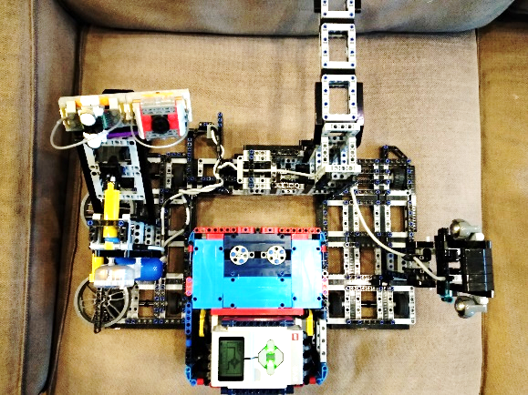

Our goal: robot designed by the team itself, unique, creative

**Innovation Elements**

This year, we use two not fixed ballast. They are very practical because it is advanced solve the tasks without motor movement and we can left them there because they are not fixed to the robot. These are used in southern and north eastern round.

This year there are lots of pneumatics used. We use them for because far from the motor drive we can also create motion. We use pneumatics in every round except the 3D printer's round.

Other than pneumatics, we use solutions without motor drive. They do their task "passively". We use these to Lander Touch-Down, the Observatory, the 3D printer, the Crater crossing.

This year we use an innovative shooter solution that we activate when the release lever is pressed against the back of the Crater crossing. This activates the shooter. Which shoot a bullet above the Crater crossing and solves this.

The gyro sensors are innovatively fixed to 2x1 rubber pieces to absorb the vibration when we go.

Our attachment mechanism consists of a innovative attachment (clamped to the inside of the robot with small wheels) and a robot-mounted strip. It fits without click but is very sure fit to our robot.

In our attachments we use LEGO boat weights as counterweights, because they are hard enough but they don't need too much space.

Our medium motor pass the rotation with a 3 to 3 point connection to the attachments.

**Robot Design/ Appearance**

Our goal: efficient, beneficial, elegant

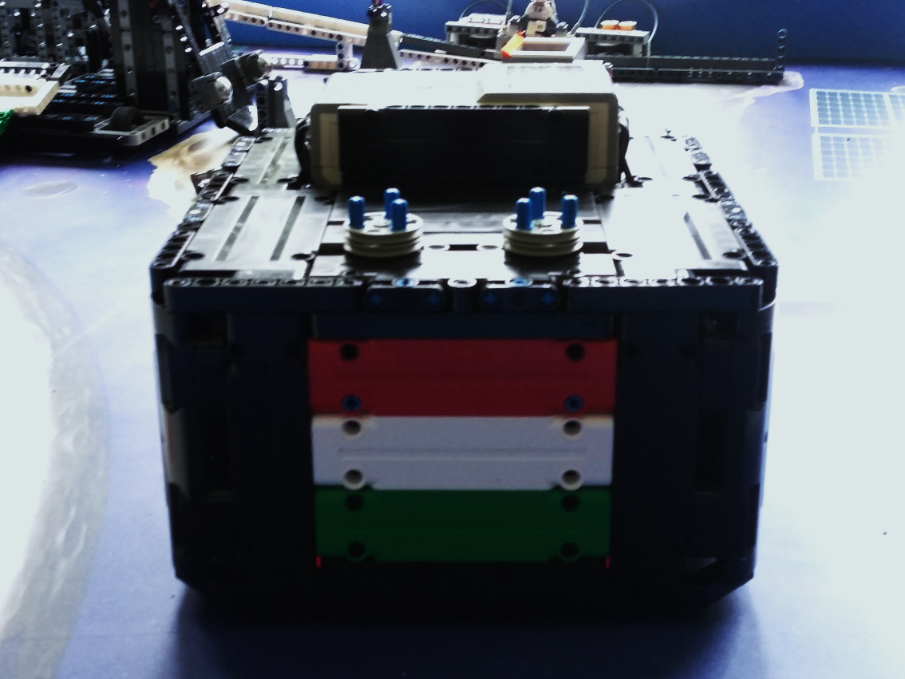Our robot’s corners are **rounded** for the **simple turning**. The sensors and the motors are placed like, they can fit on the smallest place. We build the robot in an organized and symmetrical way. This frame next to the good looking gave stability and it is easily removable. In the robot the **unified color** is **black,** but we derogated from this, and there is the **Hungarian flag.** We build the robot frame, organized and **symmetrically**. This frame next to **stability** looks good too and **easy to pick off** and **take back**. We put wheels to those attachments which go next to the wall, to avoid the friction.

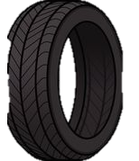

Mechanical Parts Testing

**Test: DRIVE BLOCK testing**



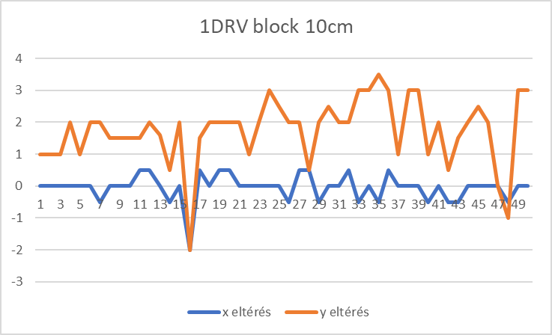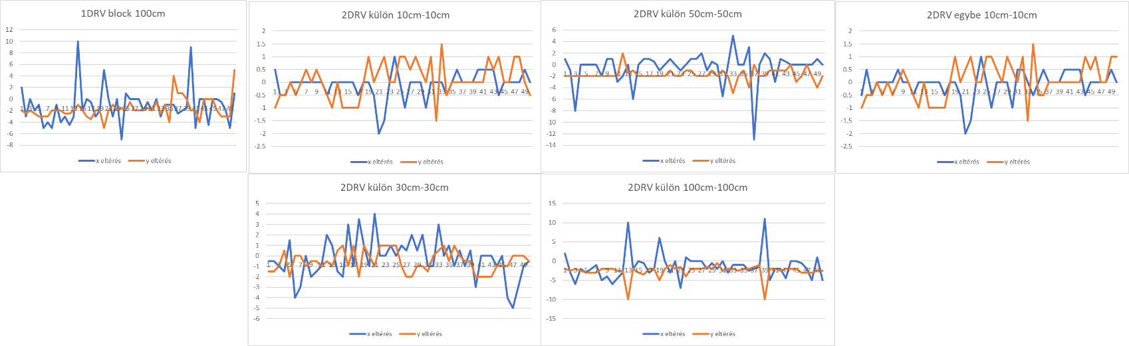

**Test: MOTOR TESTS**

At the end of the summer we tested 12 pieces of EV3 Motors from the viewpoint of reilability, performance, matching and accuracy and we selected for the race robot the two most stabile motors.

END RESULT: We have selected the two most fitting and similar, high performing motors

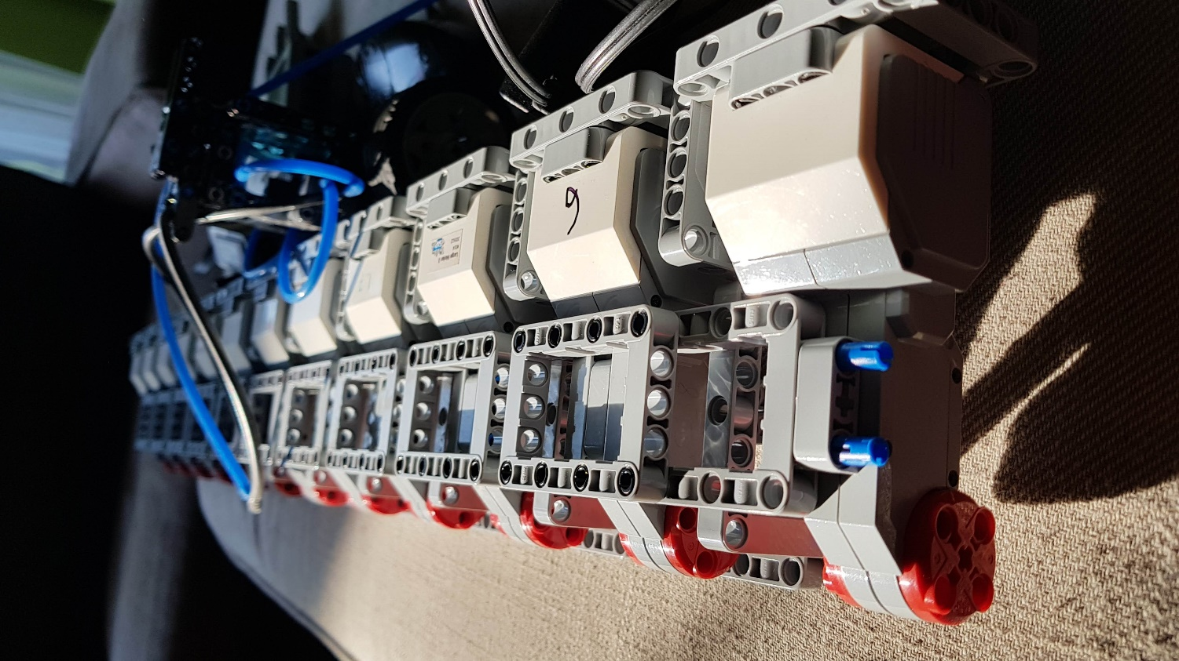

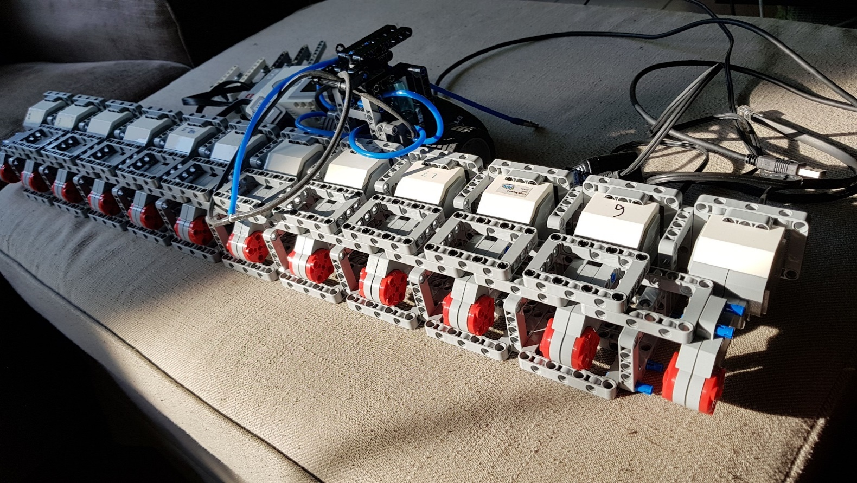

|  |  |  |
| --- | --- | --- |
|  |  |  |

**Etinesan vs EV3 Battery**

|  |  |  |
| --- | --- | --- |
| Specification |  |  |
|  | EV3 | Etinesan |
| Voltage | 7.4V | 6x 1.5V(9v) |
| mAh | 2200mAh | 6x2000mAh |
| mWh | 16280mWh | 18000mWh |
| Usefull % | 30% | 80% |
| Weight | 146g | 6x19g(114g) |
| Type | li-ion | li-polymer |

We use special batteries to power our robot instead of EV3 battery or traditional AA batteries. We choosen these

batteries consciously because with the help of it our robot can work much stable and it eventuate stable performance.

It is special because it contains a 3.7v li-polymer battery and a voltage reducator which reduces the 3.7v to 1.5.

With the help of the reducator itt can provides the 1.5v extremely stable and its voltage only dropes in the last 10%.

When we used the traditional EV3 battery, before we would put it in the competition robot we should discharge it with

the help of a battery discharger becaues when the EV3 battery are fully charged, the robot moves and turns a bit faster

and its performance is unpredictable.